Assignment 2 – Data Representation

Pairwise transformation Canonical representation

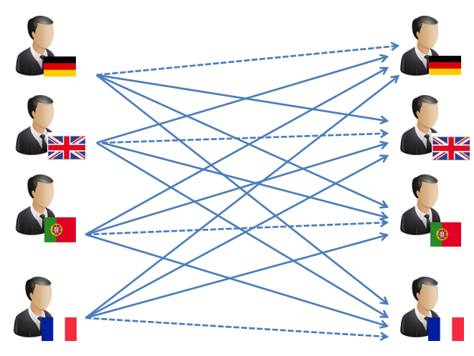 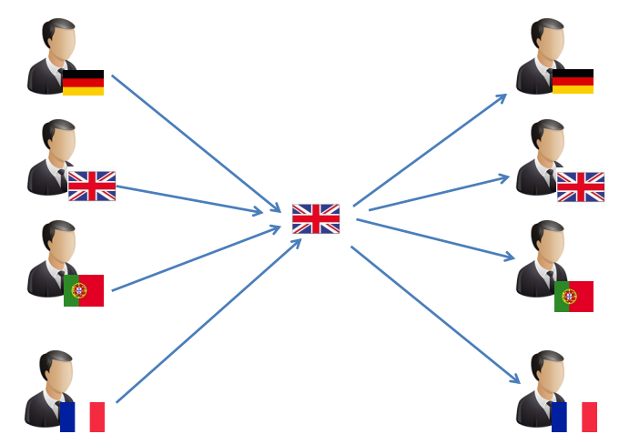

XDR vs ASN.1

ASN.1 encodes type information into the message.

* The receiver doesn’t need to know the data description.
* The messages contain additional overhead.

XDR uses blocks with multiples of 4 bytes.

* A lot of space/bandwidth is wasted with zero bits.
* Fixed length of messages reduces the computational load.

XDR doesn’t encode type information into messages

* Receiver needs to know the data description.
* The message only contains data (no meta information).

XML (XML and JSON are for data exchange in web applications)

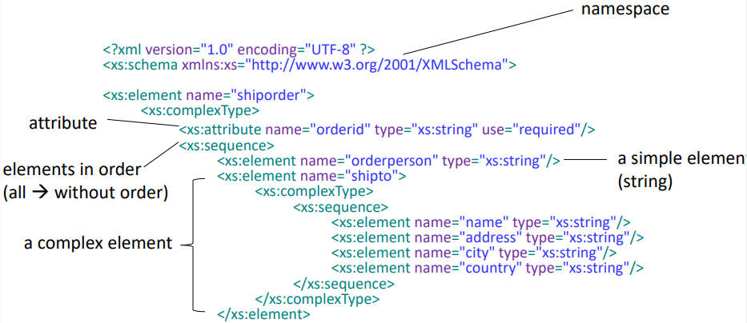

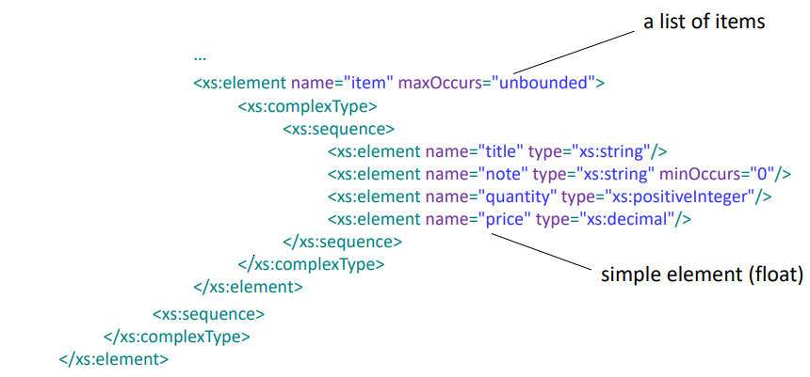

Problems with XML/JSON

* Too verbose, affects performance
* Large overhead, especially XML
* Slow to write and parse

Protocol Buffers (.proto)

* Highly efficient in writing/parsing data.
* Well documented project.
* Versioning of data structures possible.
* No RPC implementation.

Apache Thrift

* Multiple protocols to serve different purposes(binary, JSON).
* Extensions for many programming languages.
* RPC libraries included.
* Versioning of data structures possible.
* Open source project, widely used.

Apache Avro (Schema is always stored with data)

